

**————————————————————**

Weekly Assignment in *Spatial Simulation (6)*

**————————————————————**

Lecturer： Wallentin, Gudrun

Stu-Name： Chen, Yuzhou

Stu-number： s1104123

Major： Applied Geoinformatics

Winter semester, 2023

## Urban growth of Salzburg city with an integrated evaluation system

[This document of model design was collaborated by Yuzhou Chen and Haoyu Cao.]

## Introduction

Urban growth is the spatial growth of city limits over time. The study of urban growth is of great significance in several fields, including urban development, planning, environment, society and economy. Therefore, being able to accurately predict urban growth trends has become a great challenge for current society. Agent-based spatial simulation methods have considerable potential for modeling urban growth and support the input of raster and vector geographic data. In order to discover the urban expansion pattern of the city of Salzburg, we design a scenario that takes into account a series of factors affecting urban expansion, such as surface slope, city center, roads, and water bodies (Kumar et al., 2021). In addition, we show the specific simulation process of the methodology by means of UML modeling. The data inputs, simulation process, and data outputs are clear in the UML diagrams, and presenting the simulation as UML diagrams helps in the subsequent development of the urban growth program.

## Methods

Considering the requirements in the instructions, our project aims to simulate the urban growth based on the theory of an integrated urban index evaluation system. There are mainly 6 essential constituents to be taken into account: **1) The land use plots**, indicating the extent of urban expansion, which is the main task of this simulation; **2) The road**, including different road types, guiding the extension of the city in a sector model; **3) The slope**, which indicates the degree of land surface relief, is a limiting factor for urban expansion, especially in hilly and mountainous areas; **4) The city centers**, consisting of real or hypothetical transportation hub locations, are indicative of the multi-center pattern that may result from urban development; **5) The water regions,** no urban growth in these areas; **6) Neighbors of non-urbanized plots**, which are the ranges dynamically delineated in the simulation to evaluate the contribution of the level of urbanization within the neighborhood of an image element to the central image element. At each simulated time step, the model calculates factor-weighted composite scores for unurbanized points and filters the range of urbanization for the next time step on the basis of the scores and additional judgment conditions (Fig 1). This will result in a long time series simulation of urban growth in Salzburg city.

When it comes to the *Input Data* of this project, all the datasets above can be imported into the GAMA model in the type of raster or vector files. So, the *land use plots* can be derived from the land use type map in Salzburg, 1830; the *road* can be a line vector stored in a shapefile with an attribute table indicating the road type (or maybe speed); the *slope* can be calculated by FABDEM in 30m; the *city centers* may be assumed by ourselves depending with some support evidence; the *water regions* can be derived from some basic geodata for Europe.

## Validation patterns

**Check that the model arithmetic logic is correct.** As the simulation proceeds, it is almost impossible for incorrect logic to produce correct results. Therefore, it is crucial to ensure that the model's logic is correct, and this can be done by means of a single-step adjustment program to ensure that the model does not make errors. The results should be checked at every fixed number of rounds of the model, and common errors are extreme results and unchanging or recurring results.

**Parameter sensitivity test.** Changing the value of a variable while holding the values of other variables constant and observing the change in the simulation results. If the change in the simulation results caused by the change in the amount of change is stable, it is an indication that it is making a valid contribution to the model. Whereas a slight change in the variable causes a large change in the simulation results, it means that the variable is too sensitive under the current parameters and further consideration should be given to the assignment of the parameters.

**Comparison with luminous remote sensing data.** The luminous remote sensing raster records the distribution and brightness of surface lights, which can be regarded as reflecting the scale and economic status of the city. Therefore, the night-light remote sensing data can be used as validation data to verify the results. Moreover, multiple periods of night light remote sensing data are available, which means that the model results can be validated multiple times in multiple periods.

**Calibration and validation with existing land use data.** Land use data is a more accurate man-made data compared to the night light remote sensing, in which the urban land can be completely equated to the area where the urban buildings are located, therefore, the land use data can not only be used to check the model results, but also to adjust the parameters of the model by comparing it with the actual urban area in the early stage of the simulation. In general, the goal of this process is to adjust the parameters in such a way that the sum of the differences between the simulation results and the actual results at the same locations in the raster values is minimized.

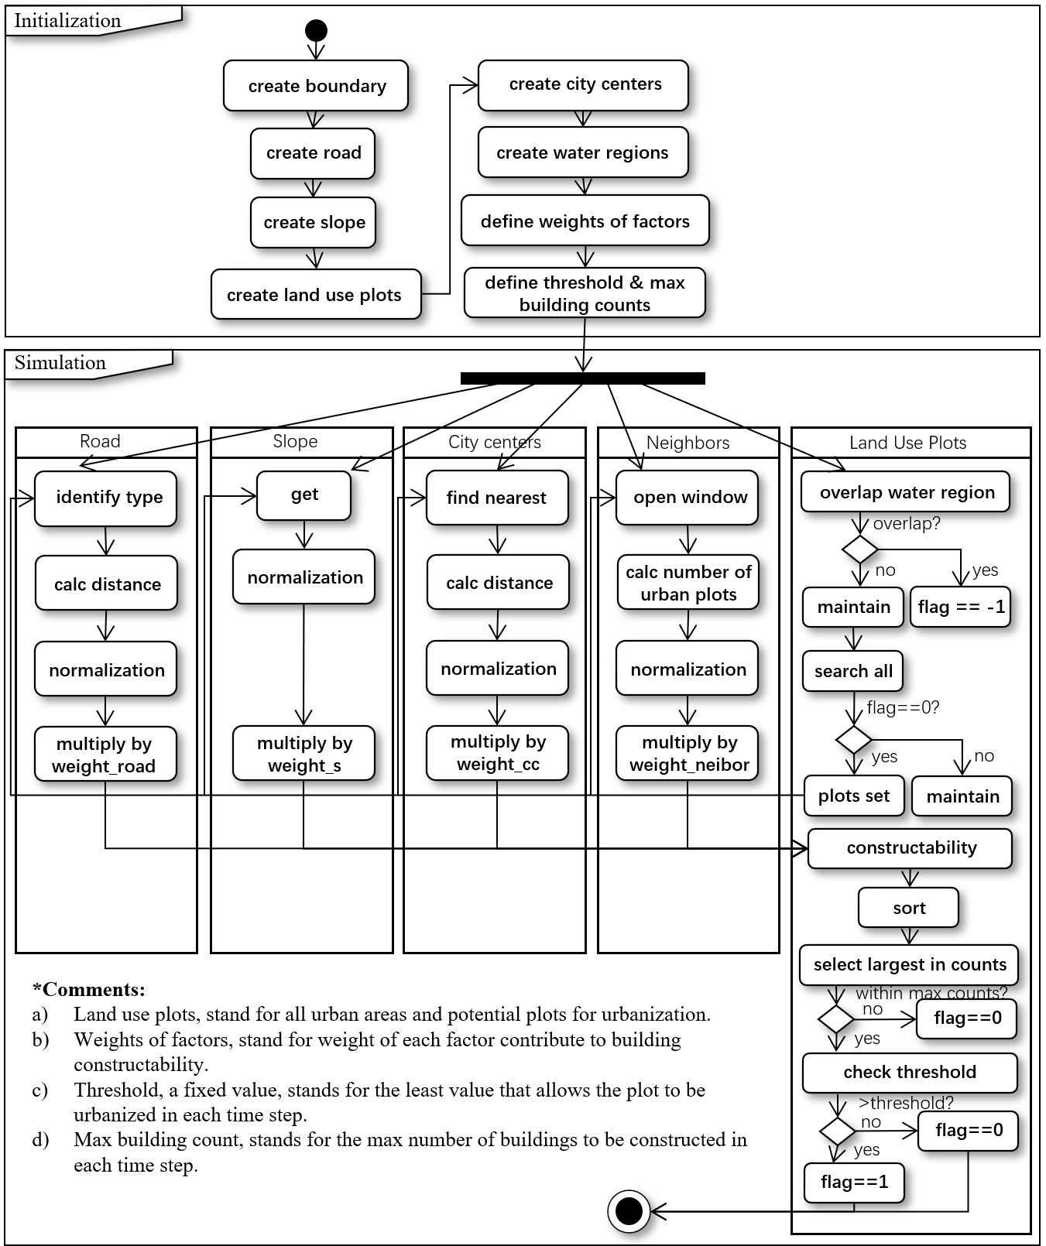

Fig 1. UML diagram: Urban Growth Model

## Result

Scenarios: To explore the performance of the model in different contexts, we chose to conduct multiple sets of experiments by setting the value of the weights of a certain variable and the weights of the rest of the variables to 0, and finally compare the experimental results. For example, when exploring the effect of slope on urban growth, we set the weights of all other factors to 0, and then adjusted the factor weights of slope to observe whether there is a significant trend in the change of the results.

According to experience, the undulation of the terrain will greatly affect the process of urban sprawl, therefore, in the final results, we firstly reclassified the operation based on the slope, and secondly counted the number of buildings in different slope intervals, if the number of buildings in low slope intervals is high, then it is in line with our perception of urban growth.

## Discussion

While discussing the issue of urban expansion under the influence of multiple factors, it's important to acknowledge that certain cities may also undergo the process of de-urbanization, characterized by a population shift away from urban areas towards suburban or rural regions.

## Reference

DiscussionKumar V, Singh VK, Gupta K, Jha AK. 2021. Integrating Cellular Automata and Agent-Based Modeling for Predicting Urban Growth: A Case of Dehradun City. Journal of the Indian Society of Remote Sensing 49 : 2779–2795. DOI: 10.1007/s12524-021-01418-2